**Project Proposal**

**On**

**Online Book Ordering**

**Management System**



Submitted by: Submitted to:

Nimesh Poudel Niman Maharjan

00174397

Computing Project

Level 5 Diploma in Computing

Softwarica College of IT & E-Commerce

Kathmandu, Nepal

Date of Submission: 4/9/2019

Table of Contents

**Chapter 1: Introduction** 5

**1.1)** **Project Introduction** 5

**1.2)** **Justification for Project** 6

**Background of project** 6

**Problem Statement** 6

**Proposed Solution** 6

**1.3)** **Description of Project** 7

**Features** 7

**1.4)** **Overview of the project** 7

**Chapter 2: Scope of Project** 8

**2.1) Scope** 8

**2.2) Limitations** 8

**2.3) Aims** 8

**2.4) Objectives** 8

**2.5) Overview of the Scope** 8

**Chapter 3: Development Methodology** 9

**3.1) Waterfall model** 9

**3.2) Design pattern used** 11

**Model view controller** 11

**3.3) System Architecture** 13

**Chapter 4: Project plan + Work Breakdown Structure** 14

**4.1) Work Breakdown Structure** 14

**4.2) Milestones** 16

**4.3) Schedule** 18

**Chapter 5: Risk Management** 20

**Chapter 6: Configuration Management** 22

**Conclusion** 23

**Bibliography** 24

**Name of the Tables**

**Tabular Structure of WBS……………………………………………………………….15**

**Milestones table…………………………………………………………………………...16**

**Likelihood table……………………………………………………………………………20**

**Consequences table………………………………………………………………………21**

**Risk management table…………………………………………………………………..21**

**Name of the Figures**

**Website Structure………………………………………………………………………5**

**Waterfall model stages………………………………………………………………..10**

**MVC pattern……………………………………………………………………………...11**

**3 tier system architecture……………………………………………………………..13**

**Time estimation table…………………………………………………………………..18**

**Gantt chart………………………………………………………………………………..19**

# **Chapter 1: Introduction**

## **Project Introduction**

My topic for the computing programming is "Online Book ordering management system" where a website is built for the organization Kitab Yatra. This website helps both the employee and the customers to interact each other very easily. This website is built to minimize the worries for the organization. Customers can easily get the desired books through this website. My website also consists books with its details. Also in my website the costumers can make their own account and give feedback to the organization about their facility. This helps the organization to do the work on the negative parts of their service and on the maintenance.



Figure 1: Website Structure

In the above figure it clearly shows that customers can sign in easily. Also they can learn about the services of the Kitab Yatra by looking at the about section. Also book can be found by the category.

My system is web based so it is build with the PHP and its supported tools. In this proposal I have also maintained the time taken to build this website in the valid time.

## **Justification for Project**

### **Background of project**

This project is built to give the excellent service to the book readers. As my project is the web based so it is very easy to use for the readers of our country. My website contains the books with their authors. It is built to maintain the fast home delivery service for books.

### **Problem Statement**

Nowadays readers are increasing very vastly in the country. As readers are increasing they want to read a various books. Also they want the book in their home by one click so that they should not go shop to buy books. Also they want the books of various categories. So by looking at this problem I decide to build the website in which all the books are available and also the books are shipped to the readers in minimum 24 hrs.

And my website in build in the best web programming language called PHP which can minimize the tons of errors. As the website is build by the student this doesn't bear any cost. But if this website will be built for the organization in the real life scenario it will cost some amount.

### **Proposed Solution**

For the solution I am building up the application from which the readers can easily buy the books of their own choices and enjoy reading. Website services will be 27*7 hours active so that reader won't get any issue in ordering the book.

To make the services better I have analyzed and visited some of the similar type of website which will more be helpful to me to learn and to build a complete book ordering website.

## **Description of Project**

### **Features**

* Online book service
* Have all categories of books
* Have well secured login system
* Feedback to the organization can be given
* High usability
* Interface of the website if easy

## **Overview of the project**

This project is build to give a well managed service to the book readers of their desired categories. My project is build by the help of PHP and its related tools to maintain the standard of the website. Project will be full concentrated on making the online book ordering management system which will in future give an ease facility to the book lovers.

As project will be web based it will be reliable and trustable.

# **Chapter 2: Scope of Project**

## **2.1) Scope**

* My project helps the readers to find the books of their desired categories.
* My project help the organization to get feedback on their services.
* This project will secure the customers ID
* Its gives the opportunity to readers to be engage with books

## **2.2) Limitations**

* To use some features user need the internet facilities
* Customer can only buy a one book at a time.
* This application need browser to open.

## **2.3) Aims**

* To give a quick services to the customers.
* To give a varied number of books to the customers.
* To help the readers to feel easy to buy a book staying at home or to make the effective way for the readers to reach books of their interest.

## **2.4) Objectives**

* To make a reading country.
* To add more number of readers in the country.

## **2.5) Overview of the Scope**

As my website is build with the help of the PHP and its supporting tools, also with the help of the HTML and CSS, it could be more easy to use by the customers of the person who click the website. As the data is stored in the MySQL, data is preserved and securely kept so that data are not lost in the future.

# **Chapter 3: Development Methodology**

There are different methodology of manufacturing the software. Some of them are iterative, extreme programming, waterfall, incremental development etc. But for my project I will choose that development methodology which will be beneficial for me throughout my completion of project.

## **3.1) Waterfall model**

I choose the methodology of developing my project with the help of Waterfall model because my project is a small and student project, and this type of project is develop to make a good example for others or to teach others. So for this type of project waterfall model is very much perfect. In the waterfall model every step should be completed and only move to the next step. As waterfall model is best for the small scale organization, I use this model for manufacturing my website. **WaterfallModel** illustrates the software development process in a linear sequential flow; hence it is also referred to as a **Linear-Sequential Life Cycle Model.*****(Toolsqa, 2019)***

There are some of the similar type of development methodology such as scrum, Agile, Spiral, etc. But I choose and stick with the waterfall model because of following reasons given below:

Comparison of waterfall model with Agile:

* Waterfall model is more rigid than that of agile model.
* In the waterfall model, before manufacturing the system all the requirement should be fulfilled and after the project starts there is no way of changing, so this will make the developer concentrated in the project from the starting phase.
* As the waterfall model is internal phase of developing, it doesn't require the customer's opinion so that this methodology is fruitful for my student project.

Comparison of waterfall model with Scrum:

* For my student project I need to complete to complete my work by me own. And in scrum the work is subdivided to the team members which I am not allowed for my project. So waterfall model is best for me in the development.
* In the scrum every step should be shown to the manager but in the case of waterfall it is self analysis and testing. So in this reasons too, it is best for me to carry on.

Comparison of waterfall with spiral:

* As talking about the waterfall model than that of spiral, waterfall model is started taking the minimum requirements than spiral, so the quick start is available for the waterfall model.
* The certain about of discipline about the waterfall model which is lack in the spiral makes waterfall model better than spiral methodology of development.

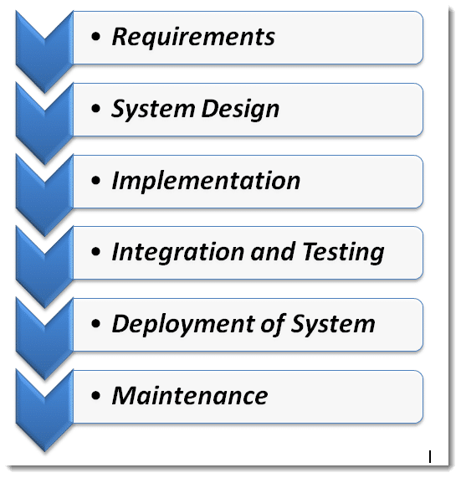

Figure 2: Waterfall model stages

## **3.2) Design pattern used**

Design pattern is a general repeatable solution to a commonly occurring problem in software design. ***(sourcemaking, 2019)***

Design patterns mainly help the development process to get in speed. Moreover, design patterns helps the developer to communicate by using the names for software interactions. For my project I decided to use the MVC pattern of designing.

### **Model view controller**

Model view controller is well recognized name in the development of the web based application. It is applied to separate the development of the application into 3 pieces and do the development process effectively and with ease.

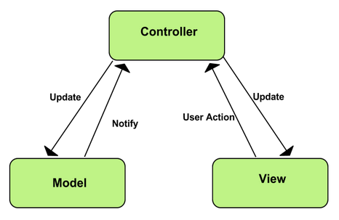

Figure 3: MVC pattern

There are many more design patterns such as web form, singleton, Proxy design pattern, etc. but I choose the MVC pattern because of following ways:

* Separation of Concerns:

MVC patterns give clean separation UI, data, model and the business logic.

* More control:

It have more control on the java, CSS and the HTLM than that of other design patterns. So as my application is web based it is better to use the MVC pattern.

* Testability:

MVC pattern provide more test options for the web based application than that of others. So it is very much fruitful to use the MVC rather than others such as Singleton, PDP, etc.

So due to this reasons I choose the MVC pattern over others.

## **3.3) System Architecture**

System Architecture is a framework that is comprised of the relationships and interactions between application components, such as middleware systems, user interfaces, and databases. ***(web-application-architecture, 2018)***

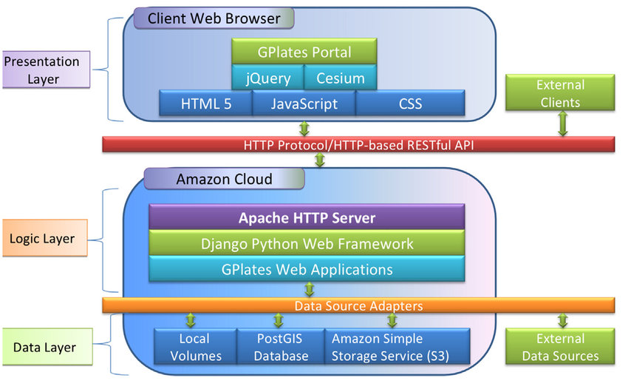

Figure 4: 3 tier System architecture

I choose the 3-Tier architecture over others because of following ways:

* It mainly gives an opportunity to develop the ability of updating the technology.
* Its gives the opportunity to work in the own expertise.
* It is more reliable than that of others.
* It provide the ease of maintaining the code.

# **Chapter 4: Project plan + Work Breakdown Structure**

## **4.1) Work Breakdown Structure**

I have planned my project to be done in the exact time. So to do that I must break down the works and separate the days for them. As my project is also an academic based so it have a deadline in which I must submit my work. So the WBS helps me to complete my work in the mean time.

To separate the time for each task, I must thoroughly analyze the task. In this analysis, I should calculate the days for each task according to their need. All the task don't contain the same amount of days.

Online Book ordering management System

Project Submission

White Box Testing

Black Box Testing

Integration Testing

Unit Testing

Coding

Building Database

Final Class Diagram

Database Design

UI Design

Behavioral Design

Class Diagram

Feasibility Study

NLA

Brainstorming

Use case Diagram

Requirement Specification

Configuration Management

Proposal Submission

Risk Management

Project Plan

Final Deadline

Testing

Analysis

Design

Implementation

Project Management

Ma

Work Breakdown Structure (WBS)

|  |  |  |
| --- | --- | --- |
| WBS | Task Name | No. Of Days |
| **0** | **Online Book Ordering Management System** | **108** |
| **1**  1.1  1.2  1.3  1.4 | **Project Management**  Project Plan  Risk Management  Configuration Management  Proposal Submission | **16**  7  4  4  1 |
| **2**  2.1  2.2  2.3  2.4  2.5  2.6 | **Analysis**  Requirement Specification  NLA  Use Case Diagram  Initial Class Diagram  Brainstorming  Feasibility Study | **28**  9  2  2  2  6  7 |
| **3**  3.1  3.2  3.3  3.4 | **Design**  Behavioral Design  UI Design  Database Design  Final Class Diagram | **25**  3  15  4  3 |
| **4**  4.1  4.2 | **Implementation**  Building Database  Coding | **20**  5  15 |
| **5**  5.1  5.2  5.3  5.4 | **Testing**  Unit Testing  Integration Testing  White Box Testing  Black Box Testing | **7**  2  2  2  1 |
| **6**  6.1 | **Final Deadline and Documentation**  Project Submission | **11**  11 |

Table: Tabular structure for WBS

## **4.2) Milestones**

Milestones are very necessary to a project for developing it in the mean time. All the programmers create a date for each task of their project to finish the project in the accurate time. Milestones helps developers or programmers to be in an advantage. So, for my project too, I have set some milestones.

|  |  |  |  |
| --- | --- | --- | --- |
| S.N. | Milestone | Date | Days |
| **1** | **Project Management**  Project Plan  Risk Management  Configuration  Proposal Submission | **3/25/19 8:00 AM to 4/9/19 5:00 PM**  3/25/19 8:00 AM to 3/31/19 5:00 PM  4/1/19 8:00 AM to 4/4/19 5:00 PM  4/5/19 8:00 AM to 4/8/19 5:00 PM  4/9/19 8:00 AM to 4/9/19 5:00 PM | **16**  7  4  4  1 |
| **2** | **Analysis**  Requirement Specification  NLA  Use Case Diagram  Class Diagram  Brainstorming  Feasibility Study | **4/10/19 8:00 AM to 5/7/19 5:00 PM**  4/10/19 8:00 AM to 4/18/19 5:00 PM  4/19/19 8:00 AM to 4/20/19 5:00 PM  4/21/19 8:00 AM to 4/22/19 5:00 PM  4/21/19 8:00 AM to 4/22/19 5:00 PM  4/23/19 8:00 AM to 4/28/19 5:00 PM  4/29/19 8:00 AM to 5/7/19 5:00 PM | **28**  9  2  2  2  6  7 |
| **3** | **Design**  Behavioral Design  UI Design  Database Design  Final Class Diagram | **5/8/19 8:00 AM to 6/1/19 5:00 PM**  5/8/19 8:00 AM to 5/10/19 5:00 PM  5/11/19 8:00 AM to 5/25/19 5:00 PM  5/26/19 8:00 AM to 5/29/19 5:00 PM  5/30/19 8:00 AM to 6/1/19 5:00 PM | **25**  3  15  4  3 |
| **4** | **Implementation**  Building Database  Coding | **6/2/19 8:00 AM to 6/21/19 5:00 PM**  6/2/19 8:00 AM to 6/6/19 5:00 PM  6/7/19 8:00 AM to 6/21/19 5:00 PM | **20**  5  15 |
| **5** | **Testing**  Unit Testing  Integration Testing  White Box Testing  Black Box Testing | **6/22/19 8:00 AM to 6/28/19 5:00 PM**  6/22/19 8:00 AM to 6/23/19 5:00 PM  6/24/19 8:00 AM to 6/25/19 5:00 PM  6/26/19 8:00 AM to 6/27/19 5:00 PM  6/28/19 8:00 AM to 6/28/19 5:00 PM | **7**  2  2  2  1 |
| **6** | **Final Deadline and Documentation**  Project Submission | **6/29/19 8:00 AM to 7/9/19 5:00 PM**  6/29/19 8:00 AM to 7/9/19 5:00 PM | **11**  11 |

Table: Milestone of the project

In the above milestone table, I have classified the days for each task. I have given a 16 days for Project management, analysis for 28 days, 25 days for design, and 20 days for implementation, 20 days for testing and to submit the final document for 11 days.

For Project management I have given 16 days because it is the initial stage of my project. In that section I must have a preplan and the discussion about my project. In that section I have divided some days on the 4 parts. That division is most important in my project.

Also, I have divide the 28 days for analysis. Analysis need a more days than others because it is the most important part of my project. Without the analysis project will be freeze down. So to get my project in speed in the future, I have separated the more days for that section.

For the design I have decided to give the 25 days. Design is also the important phase of my project. In that time I will deal with the UI design, database design, and will complete my final class diagram. For UI design I have given more days of the design section because UI is the face of any project. If face is attractive than it will be beneficial for the users to understand and to use it easily.

Similarly. For the implementation I have divided 20 days. As we all know that coding is the core part of any project. Without the coding the system doesn't run. So it needs more time to be implemented. So due to this reason I have separated the 20 days in the implementation section of my project.

Also, for the testing section I have given 7 days. Yes, off course for the testing developer will take more time, but as this is academic project and also it's not for the sale or the demanded project. So I have decided to complete my all test in the 7 days.

And at the last section of full documentation I have decided to give 11 days because the detail of my project will be in the final document so it need me more time to complete that. So due to that reason I have decided to give 11 days.

## **4.3) Schedule**

In this section of the project, I will divide the days and schedule them for my working days. So for scheduling I prepare the Gantt chart here for this project. A Gantt chart, commonly used in project management, is one of the most popular and useful ways of showing activities (tasks or events) displayed against time. ***(Gantt, 2019)***

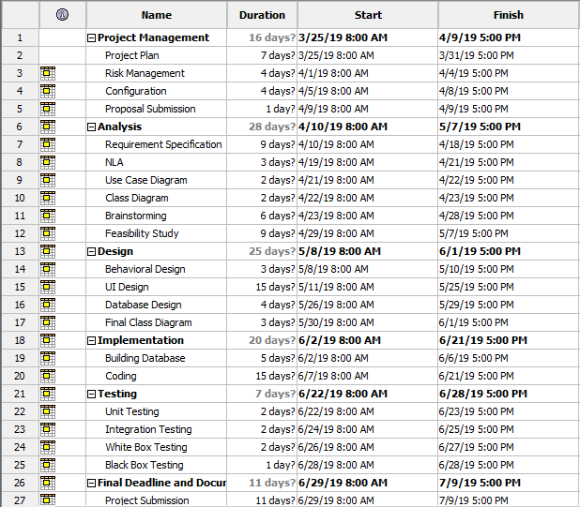

Figure 5: Time estimation table

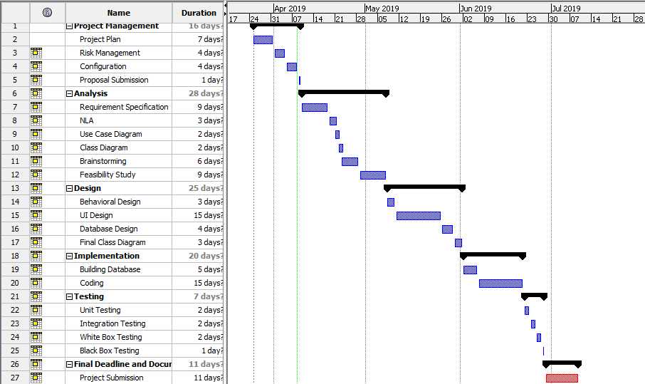

Figure 6: Gantt chart

# **Chapter 5: Risk Management**

Risk management is the process of identifying, assessing and controlling threats to an organization's capital and earnings. ***(techtarget, 2019)*** Risk management are done to verify and to analyze the risk that are seen on the future and to deal with it in the proper way. In this project also there might be some of the risk factor that must be analyze by me to outcome the best project.

For my project there might be many risks, so to deal with it I should find out the impact of the risk. And impact are found out by looking at the combination of likelihood and consequences.

Steps for risk management:

* **Risk identification**

In this step risks are discussed and following are the risk that I found:

* + Natural disaster
  + Hardware or software crash.
  + System may get infected with virus
  + Insufficient time
  + Requirements may not be found easily

* **Analyze the risk**

In this step likelihood and consequences of risks are determined.

* **Find out the impact**

In this step impact are found by likelihood * consequences.

* **Find out the solutions of risk**

In this step actions are taken to minimize the risk.

|  |  |
| --- | --- |
| **Likelihood (L)** | **Value** |
| Low | 1 |
| Medium | 2 |
| High | 3 |

Table: Likelihood

|  |  |
| --- | --- |
| **Consequences (C )** | **Value** |
| Very Low | 1 |
| Low | 2 |
| Medium | 3 |
| High | 4 |
| Very High | 5 |

Table: Consequences

|  |  |  |  |  |  |
| --- | --- | --- | --- | --- | --- |
| SN | Risks | Likelihood | Consequence | Impact | Actions |
| 1 | Natural disaster | 1 | 5 | 5[1*5] | Backup plan |
| 2 | Hardware or software crash | 2 | 3 | 6[2*3] | Maintenance |
| 3 | System may get infected with virus | 2 | 4 | 8[2*4] | Antivirus Software |
| 4 | Theft | 3 | 2 | 6[3*2] | Backup |
| 5 | Insufficient time | 3 | 3 | 9[3*3] | Must keep milestone on mind |
| 6 | Requirements may not be found easily | 3 | 1 | 3[3*1] | Should take an example of similar type of web application |

Table: Risk management analysis

# **Chapter 6: Configuration Management**

# **Conclusion**

So in this way the project of mine will be completed in the mean time. My project is based on the online book ordering management system for the organization called Kitab Yatra. As I have mentioned in above, the project will be made with the help of PHP and its supporting tools. The aim of my project will be to make a good website for the readers of Nepal with the supporting features and that can be easy to use.

I have also divided the time on the above section which will help to touch the milestone in the meantime. I have taken the waterfall model to develop my project by analyzing the scenario.

I have also classified the risk and its solution in the above section to minimize the errors and to make a standard application of my project.

# **Bibliography**

Toolsqa. (2019). *SDLC Waterfall Model*. [Online] Available at: <https://www.toolsqa.com/software-testing/waterfall-model/> [Accessed 5 April. 2019].

Source making. (2019). *what is Design pattern?* [Online] Available at: https://sourcemaking.com/design_patterns [Accessed 6 April. 2019].

Svitla. (2018). System Architecture. [Online] Available at: <https://svitla.com/blog/web-application-architecture> [Accessed 7 April. 2019].

Gantt. (2019). *What is a Gantt chart?* [Online] Available at: <http://www.gantt.com/> [Accessed 8 April. 2019].

Search compliance techtarget. (2019). *What is a Risk management?* [Online] Available at: <https://searchcompliance.techtarget.com/definition/risk-management> [Accessed 8 April. 2019].